AWS Disaster Recovery & Business Continuity Platform
Technical implementation record, commercial perspective, evidence register, and project limitations
Primary Region: Mumbai (ap-south-1) | DR Region: Singapore (ap-southeast-1)

1. Executive Summary
This portfolio project demonstrates image-based recovery of a small Apache web application from a primary AWS Region in Mumbai to a secondary Region in Singapore. It also demonstrates S3 object version recovery and creation of an AWS Backup EC2 image recovery point. The project is a manually operated recovery demonstration, not an automated high-availability or automatic failover solution.

2. Scope and boundaries

Included
- Primary VPC and web application in Mumbai (ap-south-1).
- Separate recovery VPC and recovery application instance in Singapore (ap-southeast-1).
- EC2 AMI creation and cross-Region AMI copy.
- Apache HTTP Server installation and browser verification.
- S3 bucket with versioning and a test of downloading an older object version.
- AWS Backup on-demand EC2 image recovery point with a configured 7-day retention period.
- Manual cost-conscious operation with both EC2 instances stopped when not testing.

Explicitly out of scope
- Automatic failure detection and automated failover.
- Lambda or Step Functions recovery orchestration.
- Route 53 health-check failover or automated DNS traffic switching.
- Database replication or application data replication; no database component has been implemented in this build.
- Production-grade multi-AZ high availability, formal compliance validation, or measured production SLA.

3. Architecture and resources
Component | Mumbai primary | Singapore recovery
Region | ap-south-1 | ap-southeast-1
VPC | DR-Primary-VPC | DR-Singapore-VPC
VPC CIDR | 10.0.0.0/16 | 10.1.0.0/16
Public subnet | DR-Primary-Public-AZ1 — 10.0.1.0/24 | DR-Singapore-Public-AZ1 — 10.1.1.0/24
Private subnet | DR-Primary-Private-AZ2 — 10.0.2.0/24 | DR-Singapore-Private-AZ2 — 10.1.2.0/24
Internet gateway | DR-Primary-IGW | DR-Singapore-IGW
Application security group | DR-Primary-App-SG | DR-Singapore-App-SG
Database security group | DR-Primary-DB-SG | DR-Singapore-DB-SG
EC2 application | DR-primary-app-AZ1; i-01d8da29a0cc81dea; Amazon Linux 2023; t3.micro | DR-Singapore-Recovery-App-01
AMI | DR-Primary-App-AMI-v1 | DR-Recovery-App-AMI-v1
Backup | AWS Backup recovery point for EC2; 7-day retention selected | AMI copy available
Note: Resource names and CIDRs above reflect the project configuration recorded during the build. Before publication, recheck the AWS console for current IDs, availability zones, public IPs, and exact route-table associations. Public IPs can change after stop/start when an Elastic IP is not used.

4. Technical implementation and verification
Workstream | Implementation / evidence | Status
Primary web application | Apache httpd active; localhost returned HTTP 200 OK; public browser access succeeded. | Verified
Primary AMI | DR-Primary-App-AMI-v1 reached Available in Mumbai. | Verified
Cross-Region AMI | DR-Recovery-App-AMI-v1 reached Available in Singapore. | Verified
Recovery instance | Launched in Singapore from copied AMI; browser test succeeded; page updated to identify DR environment. | Verified by user report
S3 versioning | Private S3 bucket created in Mumbai; versioning enabled; two object versions created; older version downloaded. | Verified by user report
S3 lifecycle | Lifecycle rule had transitions and expiration/deletion actions; rule was disabled pending policy review. | Disabled for safety
AWS Backup | On-demand EC2 backup job completed successfully; vault showed 1 recovery point; type Image. | Verified in screenshots
CloudWatch | EC2 metric dashboard opened; charts displayed no data for selected range; no alarms exist. | Inspected; monitoring not configured
EC2 cost control | Both primary and Singapore recovery instances reported Stopped; Singapore AMI Available. | Verified by user report

5. Recovery design
The current recovery mechanism is operator-driven: locate the copied AMI in Singapore, launch or use the recovery EC2 instance, verify the Apache service and web page, and provide the recovery endpoint to testers or users through a manually coordinated traffic change. Automated traffic redirection is not configured.

6. RTO and RPO — targets versus measured results
RTO (Recovery Time Objective) is the desired maximum time to restore service. RPO (Recovery Point Objective) is the maximum acceptable data-loss window. These are business targets, not the same as measured test results.
Measure | Provisional learning-project target | Measured result
RTO | Target: within 60 minutes for manual recovery of the static Apache demo, subject to operator access and launch readiness. | Not measured with a timed end-to-end exercise.
RPO — application server image | Target: last successfully created/copied AMI; the age of that image determines the recovery point. | Exact image age at a simulated outage not recorded.
RPO — S3 test object | Versioning allows recovery of an earlier object version while that version is retained. | Older test version successfully downloaded; no time-window RPO benchmark performed.
RPO — AWS Backup | A completed recovery point exists with 7-day retention configured. | Restore-from-AWS-Backup exercise not yet performed.
Do not present these targets as achieved SLAs. A timed, documented recovery exercise is required to calculate actual RTO. A timestamp comparison between the simulated failure and the latest recoverable data is required to assess actual RPO.

7. Commercial perspective

Business value
- Demonstrates a second-Region recovery option for a simple web workload.
- Reduces dependence on rebuilding the web server manually from scratch by using AMIs.
- Provides an object-version recovery demonstration through S3 Versioning.
- Adds a managed EC2 backup recovery point through AWS Backup.
- Produces repeatable recovery procedures and evidence useful for operational readiness.

Cost drivers
Cost area | Current project implication | Cost-control approach
EC2 compute | Running primary/recovery instances can incur hourly charges. | Stop instances when not testing; start only for scheduled exercises.
EBS volumes | Attached volumes continue to incur storage charges when EC2 is stopped. | Review volume size/type and remove only after confirming it is not needed.
AMI snapshots | Primary AMI and copied AMI use snapshot storage; cross-Region copying can add transfer costs. | Keep only necessary images after review; do not delete the currently required recovery AMI.
AWS Backup | Recovery-point storage may be billable during retention. | Use the configured 7-day retention for this test and review backup storage usage.
S3 | Stored objects and retained versions incur storage charges; requests can also be chargeable. | Keep test objects small; review lifecycle settings before re-enabling.
Public IPv4 | Allocated public IPv4 addresses may incur charges depending on allocation/use. | Review addresses and Elastic IPs in the console; do not release an address needed for recovery.
CloudWatch | Basic metrics differ from paid detailed monitoring, alarms, and custom metrics. | No alarms or detailed monitoring were enabled in this phase.
Networking | VPC, subnets, security groups and IGWs have no direct hourly charge, but data transfer and associated services may cost money. | No NAT Gateway or load balancer was created.

Commercial limitations
This is a learning/portfolio implementation, not a production cost estimate. Actual charges depend on account eligibility, regional rates, data volume, retention, public IPv4 allocation, and AWS pricing changes. Review AWS Billing and Cost Explorer before extending the design. No claim is made that the account is entirely free.

8. Security considerations
- S3 Block Public Access should remain enabled; the bucket is intended for private backup objects.
- SSH access should be restricted to a trusted source IP; never expose SSH to 0.0.0.0/0.
- The recovery web page uses HTTP in this learning environment; production use should include HTTPS and appropriate certificate/DNS configuration.
- The database security groups were created with no inbound rules; no database was deployed.
- The S3 lifecycle rule remains disabled until its transition and expiration settings are deliberately reviewed.
- Protect the downloaded SSH private key and never place it in GitHub or project evidence.

9. Evidence register
The user-provided reference file `screenshotforreference.docx` is the source of the embedded evidence images below. Screenshots show AWS console state for EC2, AMIs, VPC/subnets/route tables, S3, backup jobs, and the AWS Backup vault/recovery point. Some screenshots are small or composite; the narrative status table above also incorporates the user's reported test results.

Appendix A — Screenshot evidence
Evidence source: screenshotforreference.docx supplied by the project owner.

Evidence image 1
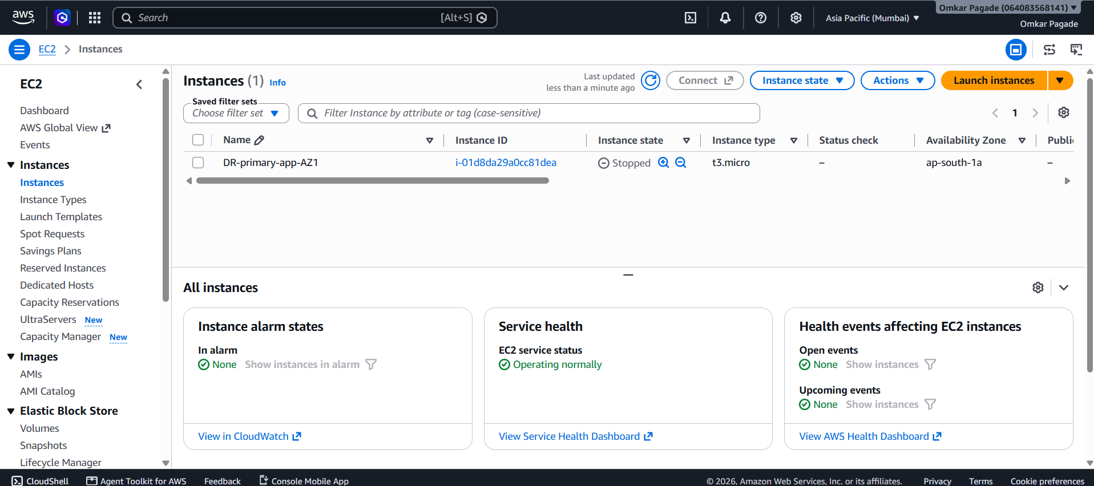
Screenshot evidence extracted from the supplied reference document (image 1).

Evidence image 2
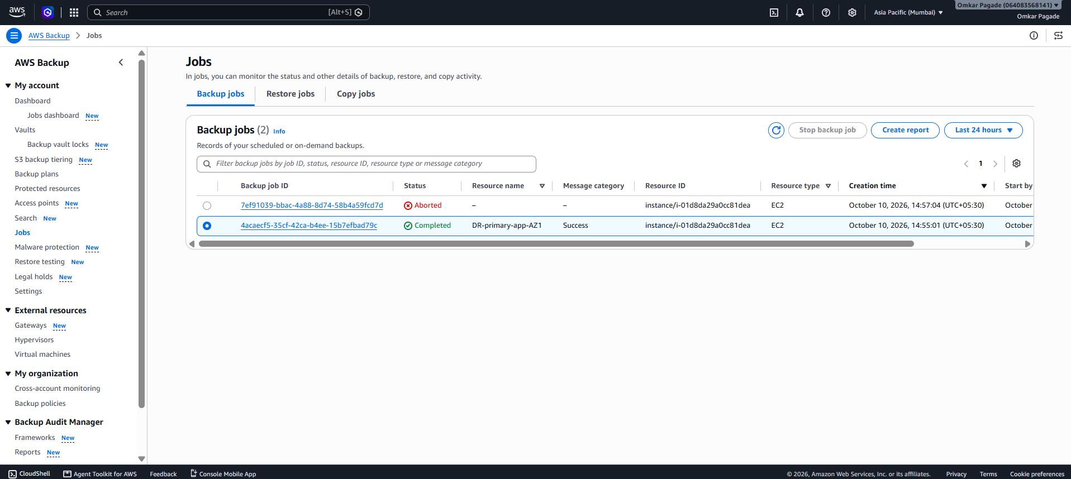
Screenshot evidence extracted from the supplied reference document (image 2).

Evidence image 3
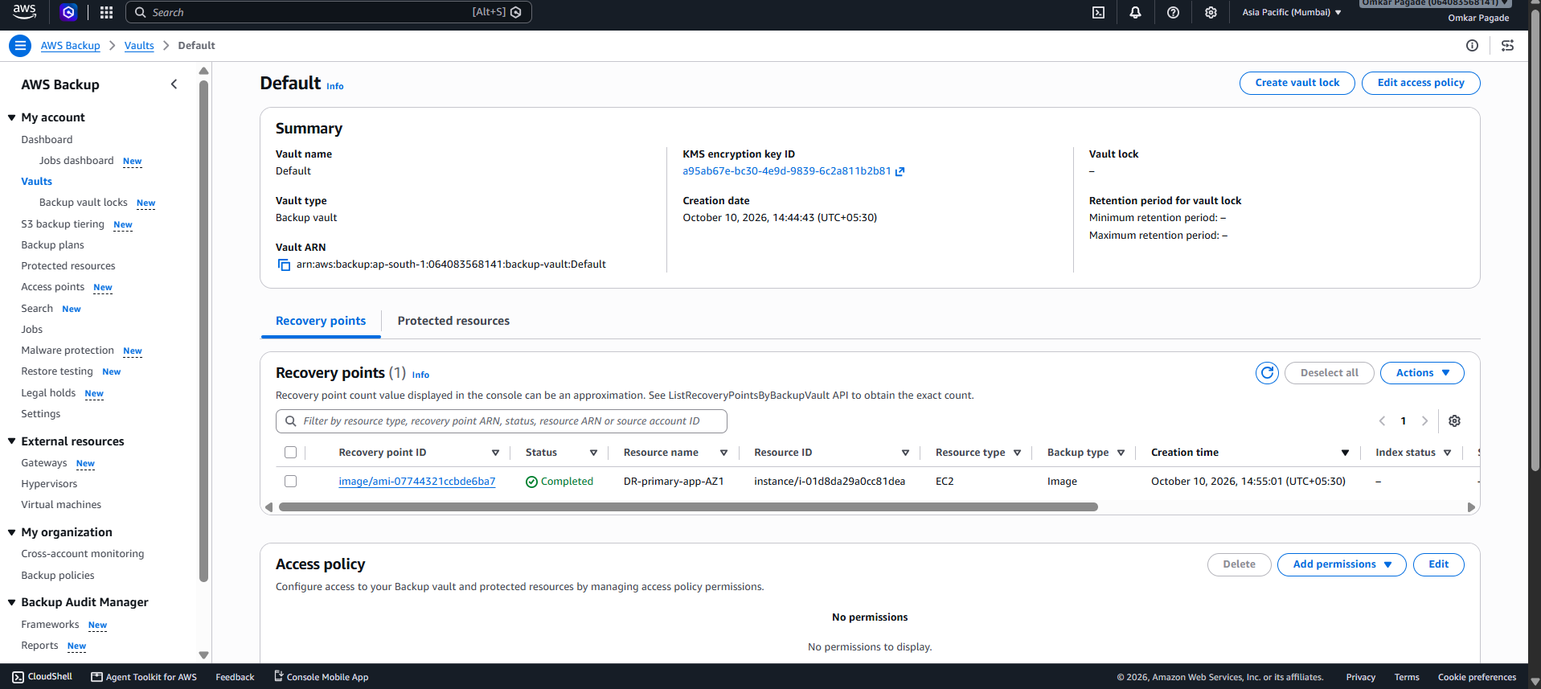
Screenshot evidence extracted from the supplied reference document (image 3).

Evidence image 4
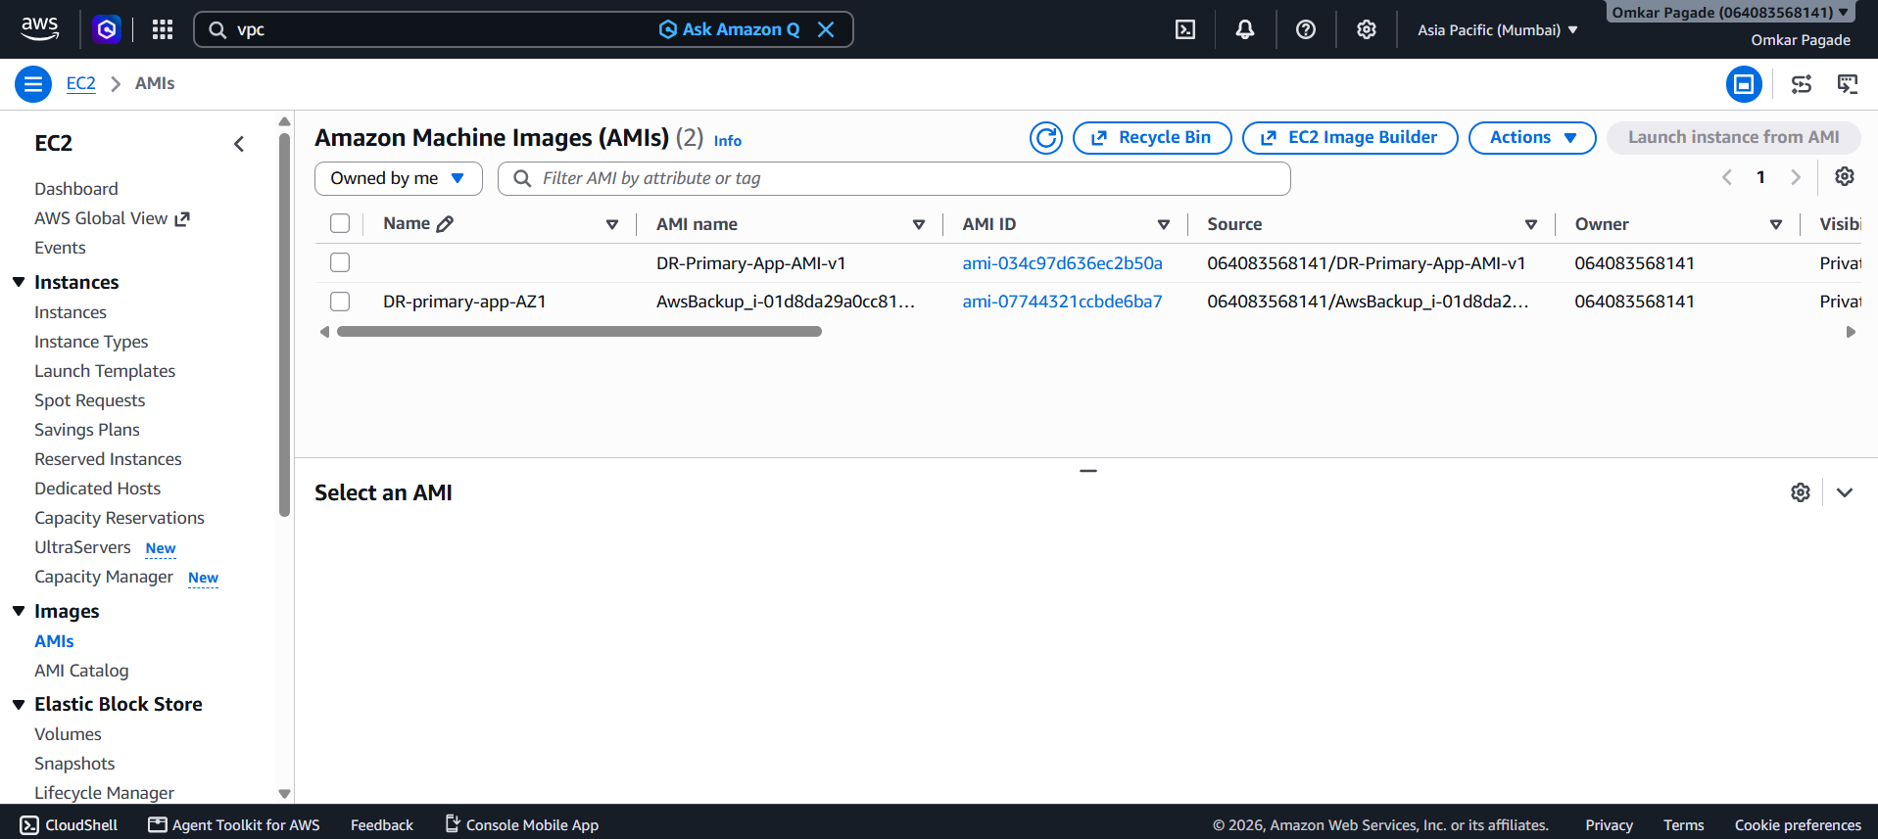
Screenshot evidence extracted from the supplied reference document (image 4).

Evidence image 5
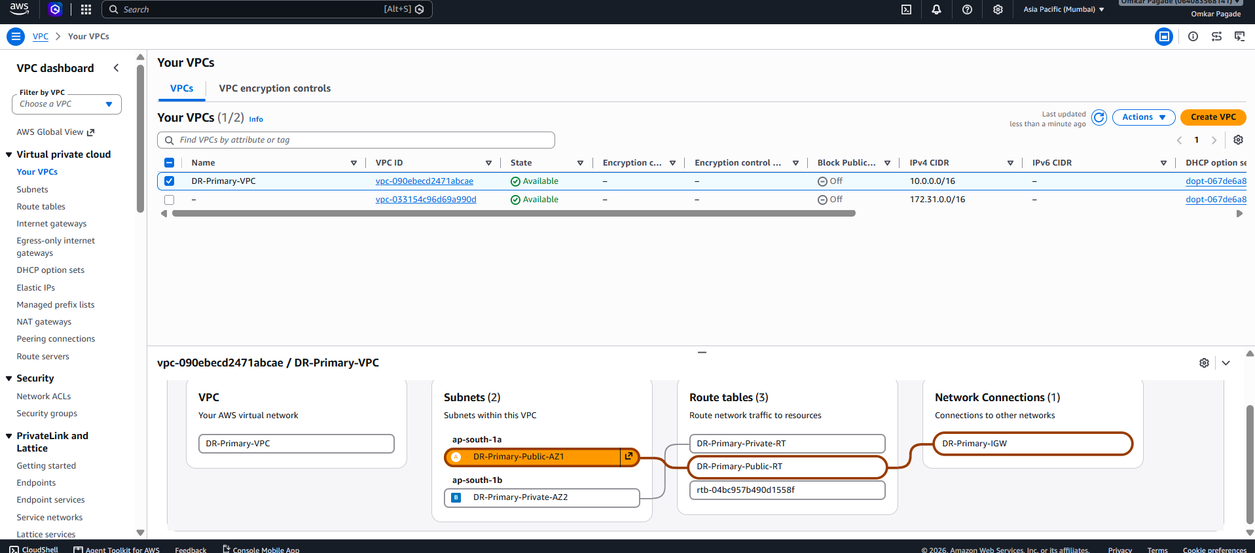
Screenshot evidence extracted from the supplied reference document (image 5).

Evidence image 6
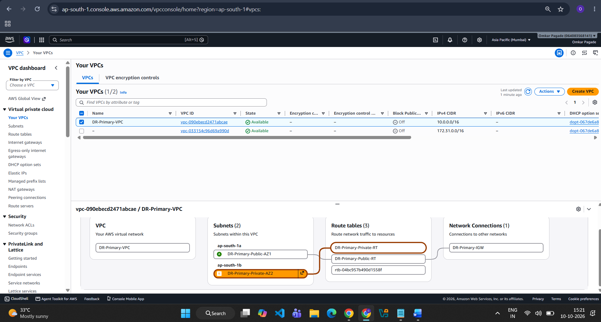
Screenshot evidence extracted from the supplied reference document (image 6).

Evidence image 7
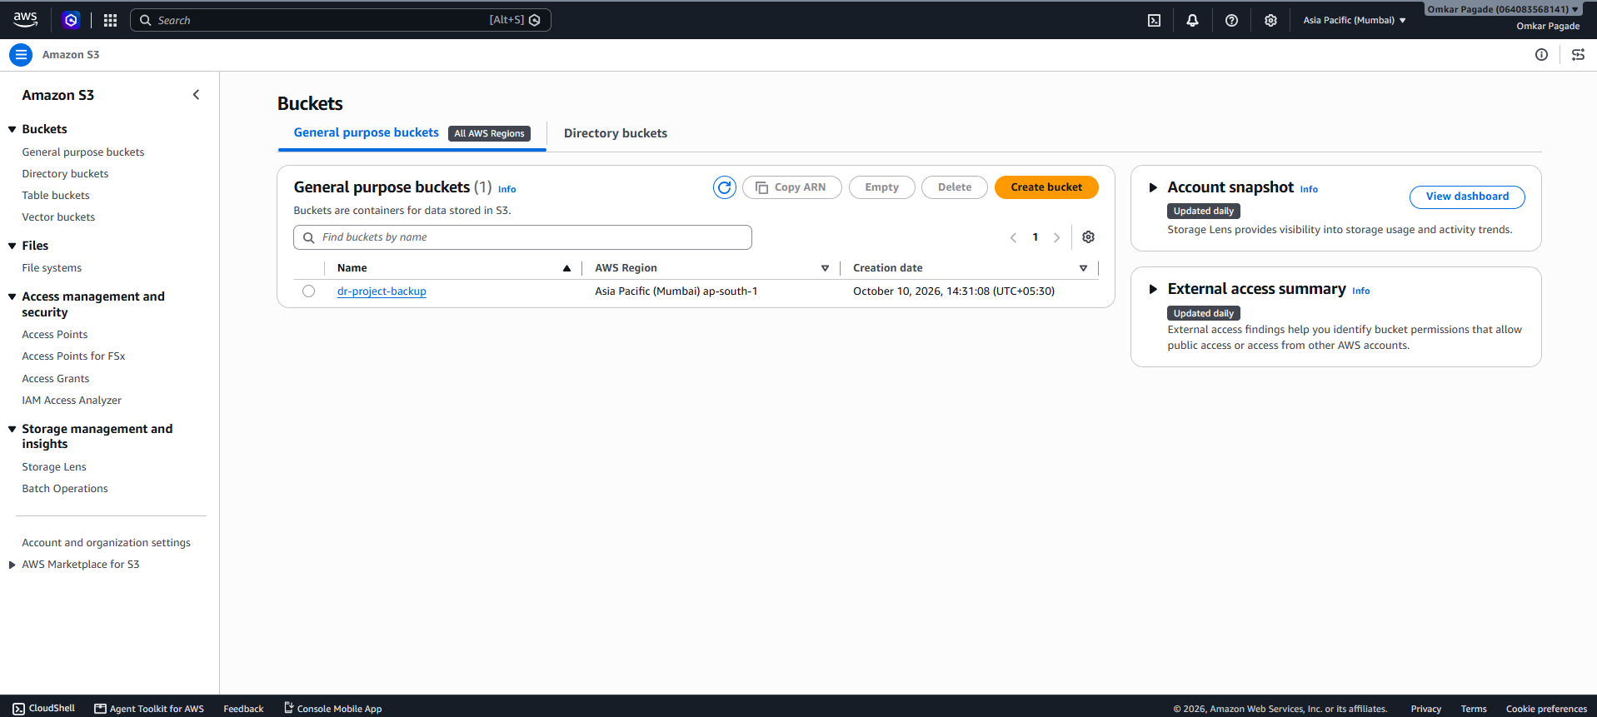
Screenshot evidence extracted from the supplied reference document (image 7).

Evidence image 8
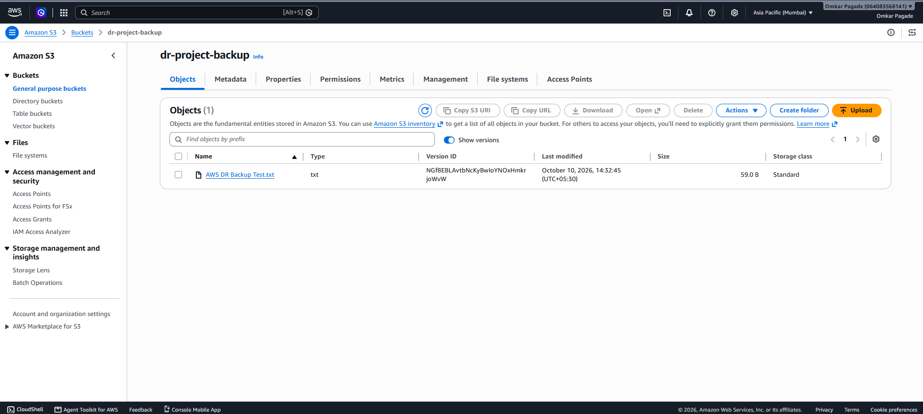
Screenshot evidence extracted from the supplied reference document (image 8).

Evidence image 9
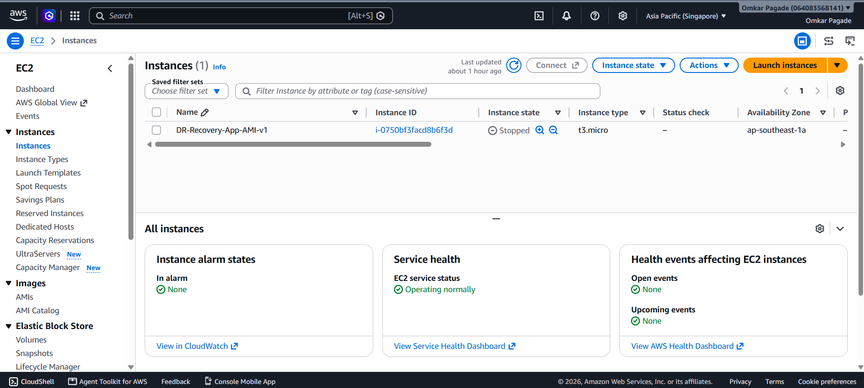
Screenshot evidence extracted from the supplied reference document (image 9).

Evidence image 10
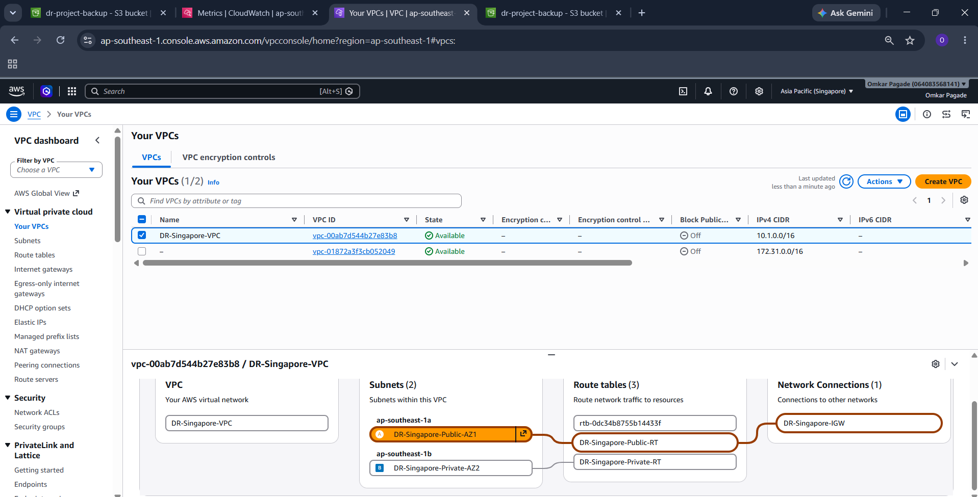
Screenshot evidence extracted from the supplied reference document (image 10).

Evidence image 11
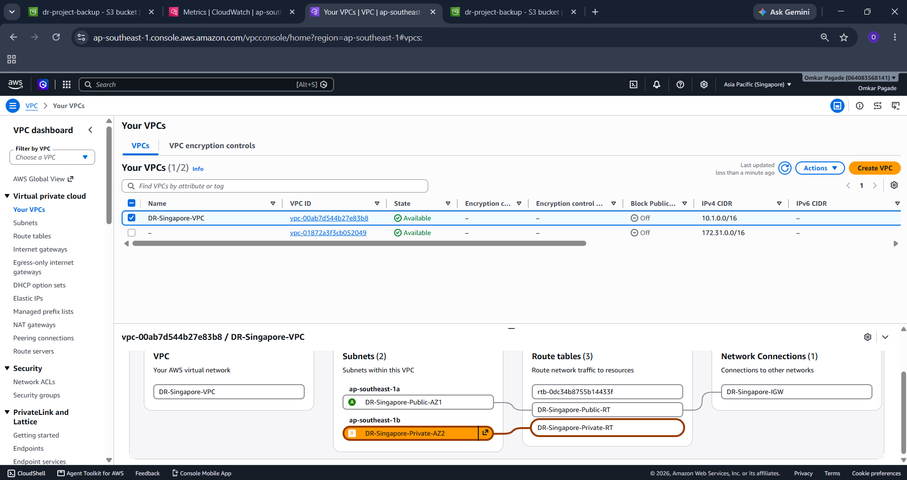
Screenshot evidence extracted from the supplied reference document (image 11).

